DIPANKAR YADAV



AGRICULTURAL AND FOOD ENGINEERING DEPARTMENT
INDIAN INSTITUTE OF TECHNOLOGY

KHARAGPUR – 721302

MASTER’S PROJECT THESIS

Submitted to Indian Institute of Technology Kharagpur
for the partial fulfillment of the requirements of
degree of
Bachelor Of Technology
in
Agricultural and Food Engineering
and
Master of Technology
in
Agricultural Systems and Management
by
DIPANKAR YADAV
(Roll No.: 21AG36011)

Under the guidance of
Prof. Ankit Shekhar
Prof. Prithwiraj Dey


AGRICULTURAL AND FOOD ENGINEERING DEPARTMENT
INDIAN INSTITUTE OF TECHNOLOGY
KHARAGPUR – 721302

Thesis submitted by

Dipankar Yadav

(21AG36011)

Approved by

Prof. Ankit Shekhar Prof. Madan Kumar Jha
Prof. Prithwiraj Dey (Head of Department)
(Supervisors)



AGRICULTURAL AND FOOD ENGINEERING DEPARTMENT
INDIAN INSTITUTE OF TECHNOLOGY

KHARAGPUR – 721302
NOVEMBER 2025

AGRICULTURAL AND FOOD ENGINEERING DEPARTMENT
INDIAN INSTITUTE OF TECHNOLOGY
KHARAGPUR – 721 302

Date: 14/11/2025

CERTIFICATE

This is to certify that this thesis entitled “Understanding Energy Use Dynamics in Indian Farms: Efficiency, Sustainability and Policy Implications” submitted in partial fulfillment of the requirements for the award of the degree of Bachelor of Technology in Agricultural and Food Engineering and Master of Technology in Agricultural Systems and Management, IIT Kharagpur, is a record of bonafide research work carried out by Dipankar Yadav, Roll No. 21AG360011, under my guidance, and no part of this thesis has been submitted for the award of any other degree/diploma.

Prof. Ankit Shekhar Prof. Prithwiraj Dey
(Supervisor) (Joint Supervisor)

DECLARATION

I certify that ,

- The work contained in this report is original and has been done by me under the guidance of my supervisors.

- The work has not been submitted to any other Institute for any degree or diploma.

- I have followed the guidelines provided by the Institute in preparing the report.

- I have conformed to the norms and guidelines given in the Ethical Code of Conduct of the Institute.

- Whenever I have used materials (data, theoretical analysis, figures, and text) from other sources, I have given due credit to them by citing them in the text of the report and giving their details in the references. Further, I have taken permission from the copyright owners of the sources whenever necessary.

Date: 14-11-2025 Dipankar Yadav
Place: Kharagpur

ACKNOWLEDGEMENTS

I would like to take this opportunity to express my heartfelt gratitude to everyone who has supported me throughout my master's thesis research and report writing. Firstly, I would like to extend my warmest thanks to my supervisors, Prof. Ankit Shekhar and Prof. Prithiwiraj Dey, for their invaluable advice and guidance throughout this journey. His extensive expertise and unwavering support have been instrumental in this research project. I am also immensely grateful to Prof. Madan Kumar Jha, Head, Department of Agricultural and Food Engineering, for providing me with the necessary facilities to carry out this research project. Lastly, I would like to express my gratitude to my parents, seniors, and friends for their unwavering assistance and motivation throughout this journey. Their constant support has been a source of inspiration for me, and I am truly grateful for their help in achieving my research objectives. Once again, I would like to extend my heartfelt thanks to everyone who has supported me throughout my master's thesis research and report writing.

Date: 14/11/2025 (Dipankar Yadav)

TABLE OF CONTENTS

Description

Chapter

Page

No.

Title Page 1
Cover Page 2
Approval page 3
Certificate 4
Declaration 5
Acknowledgement 6
Table of Content 7
Abstract 9
- Introduction 11-12
- Literature Review 13-16
2.1 Energy Use Patterns in Agriculture 13
2.2 Analytical Methods for Energy Efficiency Assessment 14
2.3 Empirical Evidence from Indian Agriculture 14-15
2.4 Global Perceptions and Comparative Studies 15
2.5 Policy, Technology Adoption, and Transition Challenges 15-16
2.6 Advanced Assessment and Research Gaps 16
- Methodology 17-35
3.1 Workflow Framework and Researech Design 17-18
3.2 Survey Design and Data Collection Methodology 18-22
3.2.1 Survey Scope 18-19
3.2.2 Survey Questionnaire Structure 19-21
3.2.3 Data Collection Procedures and Documentations Methods 22
3.3 Data Preparation and Standardization 23-24
3.3.1 Data Entry and Organization Framework 23
3.3.2 Unit Standardization 23-24
3.4 Data Preprocessing and Cleaning Procedures 24-26
3.4.1 Gap Identification and Filling and Classification Strategy 24
3.4.2 Gap-Filling Methodology 24-25
3.4.3 Indirect Parameter Estimation 25-26
3.5 Feature Engineering for Energy Conversion Analysis 26-27
3.5.1 Purpose and Goals of Feature Engineering 26
3.5.2 Sorting Fertilizers and Other Inputs by Type 26-27
3.5.3 Converting Inputs to Energy Units 27
3.6 Exploratory Data Analysis (EDA) 28-32
3.6.1 Purpose and Methods of Exploratory Analysis 28
3.6.2 Basic Descriptive Statistics 28
3.6.3 Visulization and Graphical Exploration 28-31
3.7 Energy Use Efficiency Analysis Methodology 32-35
3.7.1 Basic Concept and Calculation Steps 32-33
3.7.2 Calculation Enegry Output and Crop Energy Values 33
3.7.3 Crop-Level Energy Analysis by State 33-34
3.7.4 Breaking Down Energy Use by Input Type 34-35
3.7.5 Comparing Across Different Crops and Areas 35
References 36-38

ABSTRACT
Energy has always been central to agriculture, from the sunlight that plants need to grow to the diesel farmers use to work their fields. But farming has changed significantly. Instead of relying on natural energy sources and human labor, modern agriculture increasingly depends on diesel pumps, chemical fertilizers, and electric machinery. This shift has boosted productivity in terms of harvest but raises important questions: Are we using this energy efficiently? What does energy use look like when separated into renewable sources like labor and organic materials versus non-renewable sources like diesel and chemicals?
These questions drive this thesis project. This research aims to understand how energy is used in Indian farming systems by analyzing data from more than 600 farmers surveyed across different states like Uttar Pradesh, Rajasthan, Arunachal Pradesh, Telangana, Bihar and Madhya Pradesh. I collected detailed information on everything farmers use as input for crops, like water for irrigation, diesel, seeds, fertilizers, pesticides, and labor. The goal was to calculate how efficiently farmers convert energy investment into actual crop output and separately analyze resource specific energy contributions to total energy usage and overall farm efficiency.
I conducted surveys and gathered the data from 24 villages across four districts in Uttar Pradesh : Kanpur Nagar, Kanpur Dehat, Auraiya, and Fatehpur, in two phases: December 2024 and May to July 2025, capturing annual farming cycles. The dataset includes diverse crops wheat and paddy being most common, along with mustard, pulses, vegetables, millets and others across farms ranging from marginal to medium-sized operations.
After collecting the data, I systematically cleaned and organized everything into standardized units. Where farmers couldn't recall exact details, I used village-level averages from neighboring farmers as reasonable estimates. I also calculated values indirectly where farmers didn’t have much idea for example, total water applied from pump capacity and operating hours. I created visualizations showing basic patterns: dominant crops, farm sizes, irrigation dependency, and sowing methods.
My energy analysis framework follows established international standards. I'm converting all energy inputs like seeds, labor, diesel, water, fertilizers, pesticides, etc into megajoules using standard conversion coefficients from agricultural research. This allows me to calculate energy use efficiency indicators: the ratio of energy output (harvested crops) to energy input (all invested resources), net energy balance, and energy productivity. Analysis will be done separately for each crop within each state, enabling comparison of efficiency across different crops and regions.
At this stage, I have completed data collection, cleaning, and preparation with detailed exploratory visualizations. The formal energy calculations are planned for the next phase. This thesis presents the complete methodology from data collection procedures, processing choices, to analytical framework ensuring transparency and reproducibility. The research significance lies in providing concrete farm-level evidence about energy use patterns in Indian agriculture. By separately analyzing renewable and non-renewable energy, the findings can help identify opportunities for improved efficiency and more sustainable farming, with implications for farmers' decisions, research on agricultural sustainability, and policymakers designing support programs.

CHAPTER 1
INTRODUCTION

Agriculture is at the core of India’s economy, culture, and society, playing a crucial role in providing food security and employment to millions (ICAR, 2024; Singh & Kaur, 2021). However, it has been evolving rapidly due to increasing pressures from population growth, unpredictable climate changes, resource constraints, and the need to balance productivity with sustainability (Chakraborty et al., 2022; Verma et al., 2023). At the core of this transition lies the concept of energy use efficiency, which measures how productively resources transform into crop yield and influences the long-term resilience of agricultural systems (Pimentel & Stout, 1979; FAO, 2015). Energy—whether in the form of diesel and electricity powering agricultural machines and equipment or water, chemical, organic inputs, and human labor used for crop growth—is fundamental to every step of farming (Bhatt et al., 2020; Saxena et al., 2020). Understanding how efficiently this energy is used—and distinguishing the share used from renewable and non-renewable sources—forms the foundation of efforts to establish a productive and sustainable agricultural future (IRENA & FAO, 2021; Sudesh et al., 2018).

Energy use efficiency in agriculture has significance beyond improving crop production or realizing economic savings. It serves as an entry point into broader objectives such as sustainable development, climate change mitigation, and responsible resource management (OECD, 2013; United Nations FAO, 2024). As energy prices increase and environmental concerns grow, farmers, researchers, and policymakers place greater emphasis on optimizing energy flows within agricultural systems (Kannan & Elumalai, 2023; FAO, 2015). This focus is particularly important in India, where diversity in farm sizes, cropping patterns, agro-ecological zones, and technological adoption creates a wide spectrum of energy usage scenarios (Verma & Singh, 2022; Chakraborty et al., 2022).

This study delves deeply into the patterns of energy use efficiency among Indian farmers based on primary data collected through on-field surveys of 600+ farmers cultivating diverse crops across multiple regions. The study records inputs such as water use, fuel consumption, types and quantities of fertilizers, pest control chemicals, organic amendments, labor hours, and machinery operation (Sudesh et al., 2018; Bhatt et al., 2020).

Given the increasing emphasis in scientific literature on measuring, comparing, and improving energy use in crop production, the objectives of the thesis are :
- To study the energy input and output patterns in different agricultural systems in India.
- To analyze the overall energy use efficiencies and resource-wise energy use efficiencies at the crop level and regional levels.

CHAPTER 2
LITERATURE REVIEW

The study of energy use efficiency in agriculture has grown extensively as researchers realize its crucial role in promoting sustainable agriculture, optimizing economics, and mitigating climate change. This literature review integrates foundational theories, empirical observations, and policy insights with a special emphasis on India’s agricultural landscape and global evidence. It aims to build an inclusive understanding of how energy flows in agriculture, their impacts on productivity and sustainability, and the technological and social avenues that influence energy use efficiency.

2.1 Energy Use Patterns in Agriculture
Energy use efficiency is generally understood as the ratio of energy output, primarily in the form of harvested crop yield, to the energy input required for production (Pimentel & Stout, 1979). Inputs are categorized into direct energy, such as fuel, electricity, and human labor, and indirect energy, which includes the embodied energy in fertilizers, pesticides, and machinery (Food and Agriculture Organization [FAO], 2015; Sudesh et al., 2018). India has witnessed significant changes traversing from traditional renewable energy sources like animal power and organic manures towards carbon-intensive non-renewable sources, such as diesel fuel and chemical fertilizers, especially since the Green Revolution (Verma et al., 2023; Saxena et al., 2020). This transition bears implications on productivity as well as environmental sustainability, raising concerns about climate change.
Energy input-output analysis has shown substantial variations in energy use efficiency across different crops and regions in India. For example, studies have reported energy inputs for paddy ranging from 30,000 to 50,000 MJ/ha, with fertilizers and irrigation electricity representing the bulk of consumption (ICAR, 2024; Bhatt et al., 2020). Similarly, vegetable crops such as onions have demonstrated high fertilizer use intensity, accounting for approximately 45% of total energy inputs (Sudesh et al., 2018). These differences are influenced by factors including irrigation methods, mechanization, farm size, and management practices (Verma & Singh, 2022). Rainfed farming, a large share of Indian agriculture, usually exhibits lower energy inputs but is more vulnerable to climate variability (Chakraborty et al., 2022).

2.2 Analytical Methods for Energy Efficiency Assessment
Energy use in farming is assessed primarily through input-output energy budgeting, which converts different inputs into a common energy unit megajoules(MJ) enabling meaningful comparisons and aggregation (Mandal et al., 2002; Bhatt et al., 2020). Reliable energy coefficient databases form the foundation of this approach, with diesel fuel standardized at 56.31 MJ/liter and human labor at 1.96 MJ/hour in Indian studies (FAO, 2015; Sudesh et al., 2018). Input-output analysis can be supplemented by energy productivity and specific energy metrics, which reveal how efficiently inputs are converted into outputs in absolute and relative terms.
More sophisticated methods have emerged to analyze and optimize energy use. Data Envelopment Analysis (DEA) permits comparison of decision-making units such as farms or regions based on multiple inputs and outputs to identify efficiency frontiers or benchmarks (Gómez-Calvet et al., 2023; Zhang et al., 2022). Studies applying DEA to Indian contexts reveal inefficiencies, potential input reductions, and highlight the role of technological adoption and farm diversification (Kannan & Elumalai, 2023). Life Cycle Assessment (LCA) complements farm-level evaluations by encompassing the environmental impact embedded in upstream inputs, providing a cradle-to-farm-gate perspective on energy and emissions (FAO, 2015; Zhang et al., 2022). LCAs have underscored fertilizer production and use as critical hotspots of energy consumption and greenhouse gas emissions in Indian agriculture (Sudesh et al., 2018).

2.3 Empirical Evidence from Indian Agriculture
Empirical research presents a detailed picture of energy use efficiency across Indian agriculture. Multiple studies based on primary field data illustrate how cropping practices, farm size, and technology affect energy flows. Research conducted in Punjab shows that total energy inputs for paddy production often surpass 47,000 MJ/ha, with fertilizer use accounting for roughly 42% and electricity for irrigation 36%, emphasizing the climatic and resource dependency of production methods (ICAR, 2024; Bhatt et al., 2020). Similarly, analyses of integrated farming systems, combining crops, livestock, and aquaculture, have demonstrated energy use efficiency ratios exceeding 2, suggesting diversification as a promising route for better energy balance (Soni et al., 2018; Sudesh et al., 2018).
Several studies on horticultural crops such as onions and grapes reveal fertilizer energy as the dominant input (Sudesh et al., 2018; Verma & Singh, 2022). Regional variations are significant; mechanization and irrigation levels differ widely between states like Punjab, Haryana, and tribal or hilly regions, considerably affecting energy consumption patterns (Saxena et al., 2020; Verma et al., 2023). Rainfed systems prevalent in central and eastern India utilize less energy but remain highly susceptible to climate shocks (Chakraborty et al., 2022).
Overall, the relationship between energy use and productivity in India is complex. High-input systems may achieve higher yields but tend to show diminishing returns in terms of energy efficiency. Meanwhile, traditional and organic systems, though producing somewhat lower yields, often perform better on energy balance measures (Gómez-Calvet et al., 2023; Pimentel & Stout, 1979).

2.4 Global Perspectives and Comparative Studies
Globally, studies have confirmed many of the same patterns seen in India. There are researches comparing conventional and organic systems across several countries indicating that organic and conservation-based practices generally use energy more efficiently due to lower dependence on synthetic fertilizers and fossil fuels (Gómez-Calvet et al., 2023; Zhang et al., 2022). Practices such as zero tillage, crop rotation, and minimal irrigation have yielded energy savings of 8–20 percent in crop production, as revealed in global cropping system comparisons (OECD, 2013; United Nations FAO, 2024). These methods have proven effective without substantial compromise in yields.
European research further links farm energy use intensity with greenhouse gas emissions profiles, illuminating energy efficiency improvements as a core component of climate change mitigation strategies across the agricultural sector. Similar studies in other developing regions echo the Indian experience, emphasizing barriers such as technology access, credit availability, and extension support (Kannan & Elumalai, 2023).

2.5 Policy, Technology Adoption, and Transition Challenges
Significant policy efforts have sought to address energy efficiency challenges in Indian agriculture. Subsidies and programs promoting solar irrigation pumps and energy-efficient vehicles provide examples, yet their adoption remains patchy due to high upfront costs, limited awareness, and infrastructural deficits (IRENA & FAO, 2021; FAO, 2015). Access to institutional credit and cooperative networks influence technology uptake, improving market engagement and resource optimization especially among larger or more organized farmers (Bhatt et al., 2020; Verma et al., 2023).
Government and international organizations increasingly promote integrated frameworks that balance economic viability, environmental sustainability, and social equity, recognizing these as mutually reinforcing components critical for genuine energy transition in agriculture (OECD, 2013; FAO, 2015). These frameworks underpin emerging climate-smart agriculture initiatives emphasizing resource efficiency and resilience (Kannan & Elumalai, 2023).

2.6 Advanced Assessments and Research Gaps
Advanced assessment combining DEA, LCA, and econometric modeling offers powerful tools to unwind complexities in farm energy use. However, comprehensive Indian farm-level data explicitly segregating renewable and non-renewable energy flows remain scarce (Gómez-Calvet et al., 2023; Zhang et al., 2022). Social factors such as gender roles, educational levels, and access to extension services remain substantially understudied despite their influence on agricultural practices and energy use efficiency and technology adoption (Bhatt et al., 2020; Saxena et al., 2020).
More studies are needed to find out the true impacts of policies, technology deployment, and evolving climate pressures over time (Kannan & Elumalai, 2023). As energy systems and agricultural practices evolve, dynamic and spatially explicit analyses will be essential to design targeted, region-specific interventions.

CHAPTER 3
METHODOLOGY

This chapter explains the overall approach used to study energy use dynamics and energy use efficiency in agricultural farming systems across different regions of India. This thesis project involved collecting field survey data directly from farmers, organizing and cleaning that data, preparing it for analysis through energy calculations, visualizing the patterns, and then performing the actual energy use efficiency analysis. This structured approach makes sure the work is clear and properly measures how well farmers use energy in their farming practices.

3.1 Workflow Framework and Research Design
The research follows a clear workflow that moves logically from collecting raw data all the way to final analysis. The workflow has six connected stages: data collection, data preparation, data cleaning and checking, exploratory data analysis, preparing data for energy calculations, and finally the energy use efficiency analysis. This approach is based on methods used in agricultural survey research and agricultural systems studies (Benedetti et al., 2010; Division of Sample Surveys ICAR-IASRI, 2017).
Each stage in this workflow has its own specific purpose. Data collection gathers the basic information through on-field farmer surveys, recording details about all the inputs farmers use and the outputs they get. Data preparation means taking all the collected data and putting it into consistent formats and standard units so that different types of information (amounts given in kilograms, liters, hours, or other measures) can be compared and added together (FAO, 2015a). Data cleaning and checking deals with gaps, mistakes, and missing data by using fixed methods to turn the rough dataset into a more reliable dataset that can be used for analysis (ICAR-IASRI, 2017). Exploratory data analysis creates visual representations and summaries of the patterns in farms, input use, and crop systems before doing detailed calculations (Ministry of Statistics & Programme Implementation, 2024). Feature engineering changes the raw input amounts into standard energy units using conversion factors found in farming research, making the data ready for energy calculations (Gholami & Sharafi, 2015). Energy use efficiency analysis uses mathematical methods to calculate energy indicators and spot patterns of efficiency across different crops and regions (Sudesh & Malik, 2018). This step-by-step process from raw field data to processed data ready for analysis follow established guidelines for handling agricultural data from FAO sampling guidelines (FAO, 2015a) and from the Indian system for agricultural statistics (ICAR-IASRI, 2017).
Fig 3.1 : Flowchart showing the workflow followed in this project

3.2 Survey Design and Data Collection Methodology

3.2.1 Survey Scope
To make sure I was getting authentic and useful information about how farming actually works, I conducted on-field surveys by meeting directly with farmers in person across different regions. As part of a larger collaborative effort, multiple researchers conducted surveys in their geographic areas so that we could have a dataset spanning different parts of India. In my case, I conducted 125 farm household surveys in 24 villages across 4 districts in Uttar Pradesh. I did this work in two different time periods : once in December 2024 and again in May-July 2025. The choice of these two periods was deliberate; the December surveys captured how farmers manage farming in winters and what practices they use, while the May-July surveys recorded what happens during the summer and monsoon growing seasons. This helped me understand both winter and summer farming systems throughout the annual cycle (Chakraborty et al., 2022; Ministry of Statistics & Programme Implementation, 2024). My surveys focused on Uttar Pradesh, specifically in four districts: Kanpur Nagar, Kanpur Dehat, Auraiya, and Fatehpur, which represent different agricultural settings in the Indo-Gangetic Plain.
Other surveyors doing this collaborative work conducted similar surveys in the states of Madhya Pradesh, Bihar, Telangana, Rajasthan, and Arunachal Pradesh, using the same survey tools and procedures to ensure everything was consistent across the collaborative dataset. Having surveys across multiple states means we can compare energy use patterns at a regional level while also looking at region specific details.
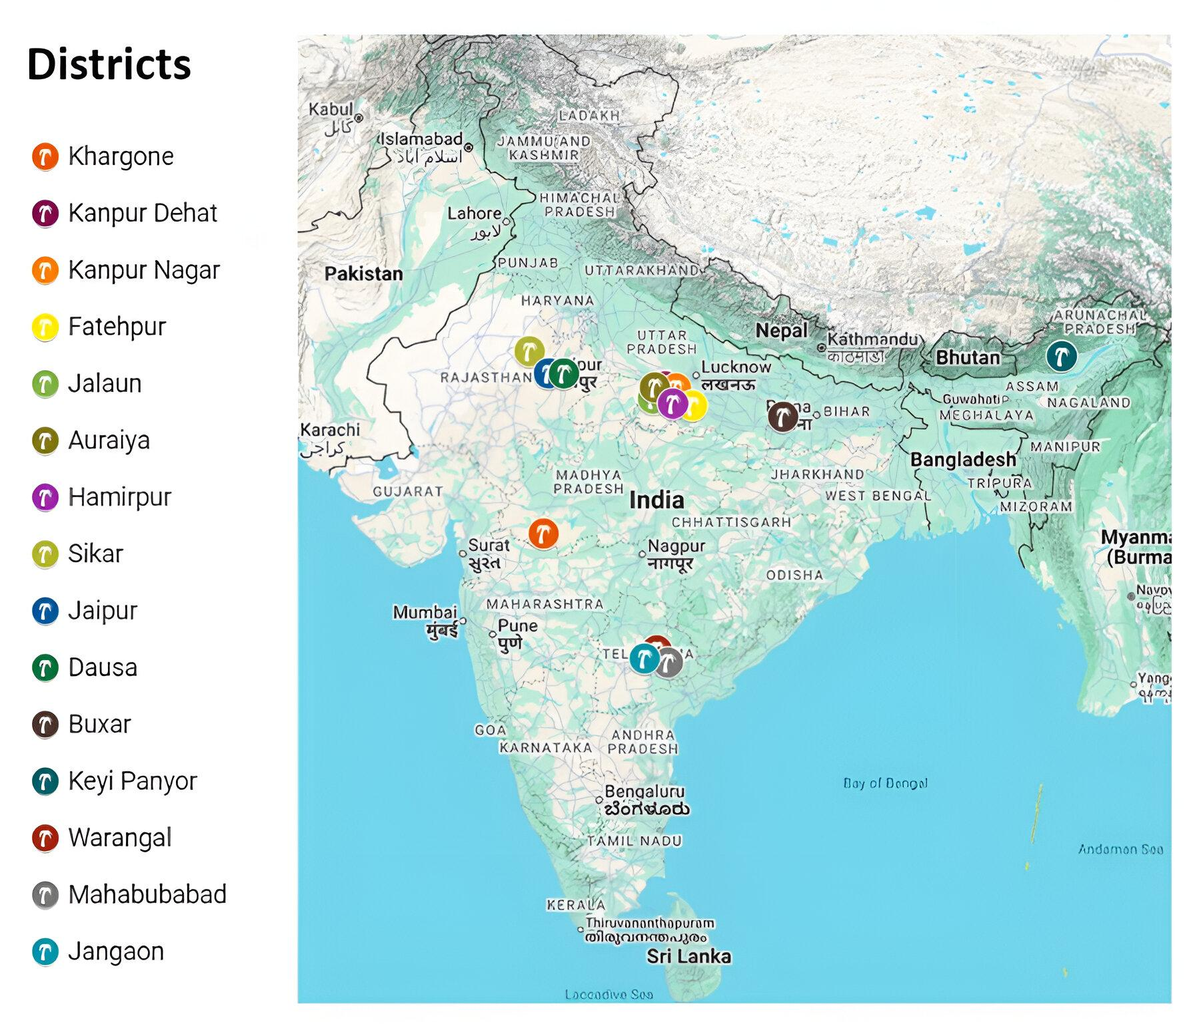
Fig 3.2: This image shows the locations of the districts on the map of India where on-field surveys were conducted

3.2.2 Survey Questionnaire Structure
The survey questionnaire used was organized into seven different sections to capture the full picture of how farming works and how it uses energy in its social and environmental setting (Ministry of Statistics & Programme Implementation, 2024).
These sections included:
(i) a special section with detailed information about farm energy usage (Verma et al., 2023)
(ii) information about the household including age, gender, education level, family size, and how much land the family owns
(iii) details about farming practices they use and whether they follow conservation agriculture
(iv) what farmers think about climate change and environmental problems
(v) their access to farming information and help from extension services
(vi) what they think about conservation agriculture and what holds them back from adopting it
(vii) any final thoughts and suggestions they had
The first section about energy and input use was the most important for this thesis because it captured everything needed for energy analysis. This section documented the total area each farmer cultivates for each crop (in hectares), what type of irrigation method they use and how much water they apply, machinery use and how much diesel they burn for different farm jobs (ploughing, harvesting, moving crops), the specific names and amounts of fertilizers and plant protection chemicals including pesticides, herbicides, and fungicides, labor measured in man-days, how much seed they use for each crop (in kilograms), whether they use mulch, how they manage crop residue, and what they harvest at the end (Sudesh & Malik, 2018; FAO, 2015b). This section also recorded what sowing method they used, whether they did it by hand (broadcasting) or with machines. Where possible, names or brands of chemicals were recorded, though farmers did not always remember exactly what they had used. The way this section was organized made sure to get all the information needed to do energy use efficiency analysis (ICAR-IASRI, 2017).
Table 3.1 : Questions included in questionnaire to conduct energy use survey
Sr No. | Survey Questions
1 | Farm Location
2 | Total area of cultivation
3 | Area of Cultivation for each crop
4 | Cropping Pattern and Sequence
5 | Area under Conservation Agriculture
6 | Do you follow Rice-Wheat
7 | Area under R-W
8 | Is it rainfed (rainfed/ wheat is irrigated/ R-W both irrigated/ other)
9 | Method of Irrigation
10 | Do you have electric/ diesel pump/ channel supplies to the farms
11 | What is the power of the pump
12 | How much water this pump draws per unit time (Q)
13 | Total hours of pump running for each crop
14 | How much water applied to each crop
15 | How much seed used for each crop
16 | How did you sow crops
17 | Machinery used for sowing
18 | Did you apply mulch? If yes, how much?
19 | How much residue do you maintain in the field?
20 | Do you use any decomposer for that
21 | Total hours of tractor operation
22 | Total hours of implement operation
23 | Name of the implements used
24 | Do you know the total diesel consumption
25 | How many labours did you use
26 | Total man days used
27 | Do you have a soil test card
28 | Are performing organic farming
29 | Name, quantity and price of fertilizers applied
30 | Name, quantity and price of herbicides applied
31 | Name, quantity and price of insecticides applied
32 | Name of fungicides applied
33 | Any other chemicals applied
34 | Yields of each crop
35 | Prices you got for selling in the last season/year

3.2.3 Data Collection Procedures and Documentation Methods
When the surveys were conducted, multiple methods were used to record things so that later it could be checked that the data was real and where each piece of information came from. Surveys were conducted by sitting down with farmers and going through the questionnaire systematically, recording what they said. To support this main data collection, three other ways were used to document things:
(i) audio recordings of each conversation with farmers were made in M4A format
(ii) digital photos of each farmer with surveyor was taken in JPG format
(iii) scanned the filled-out survey forms after farmers signed them and saved them as PDFs (Chakraborty et al., 2022).
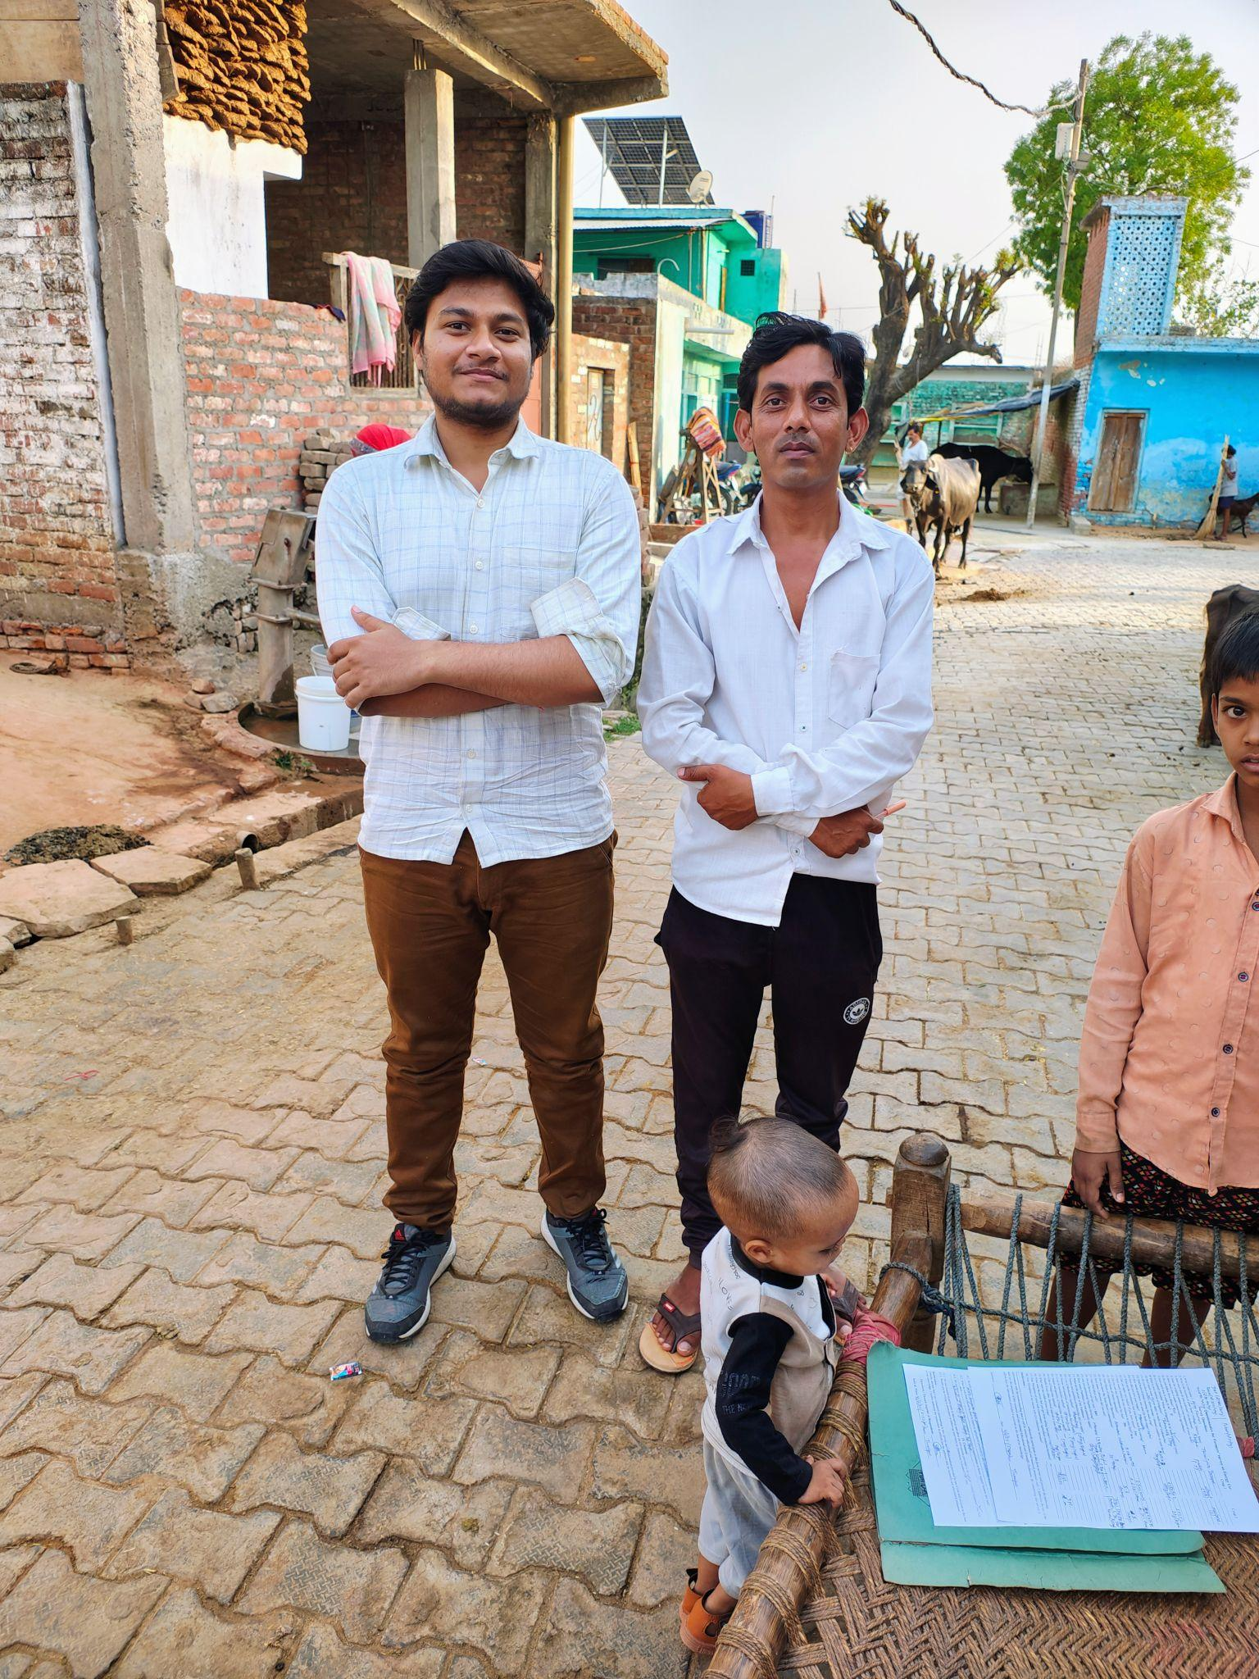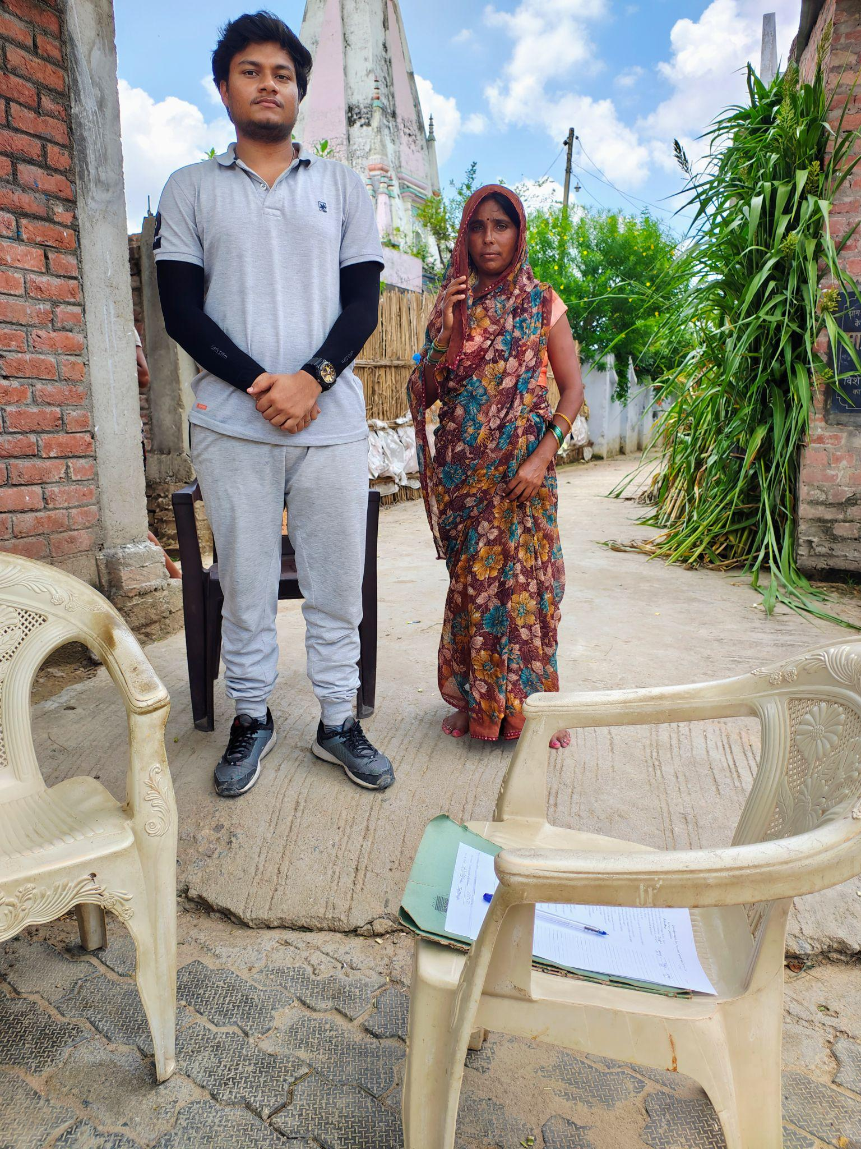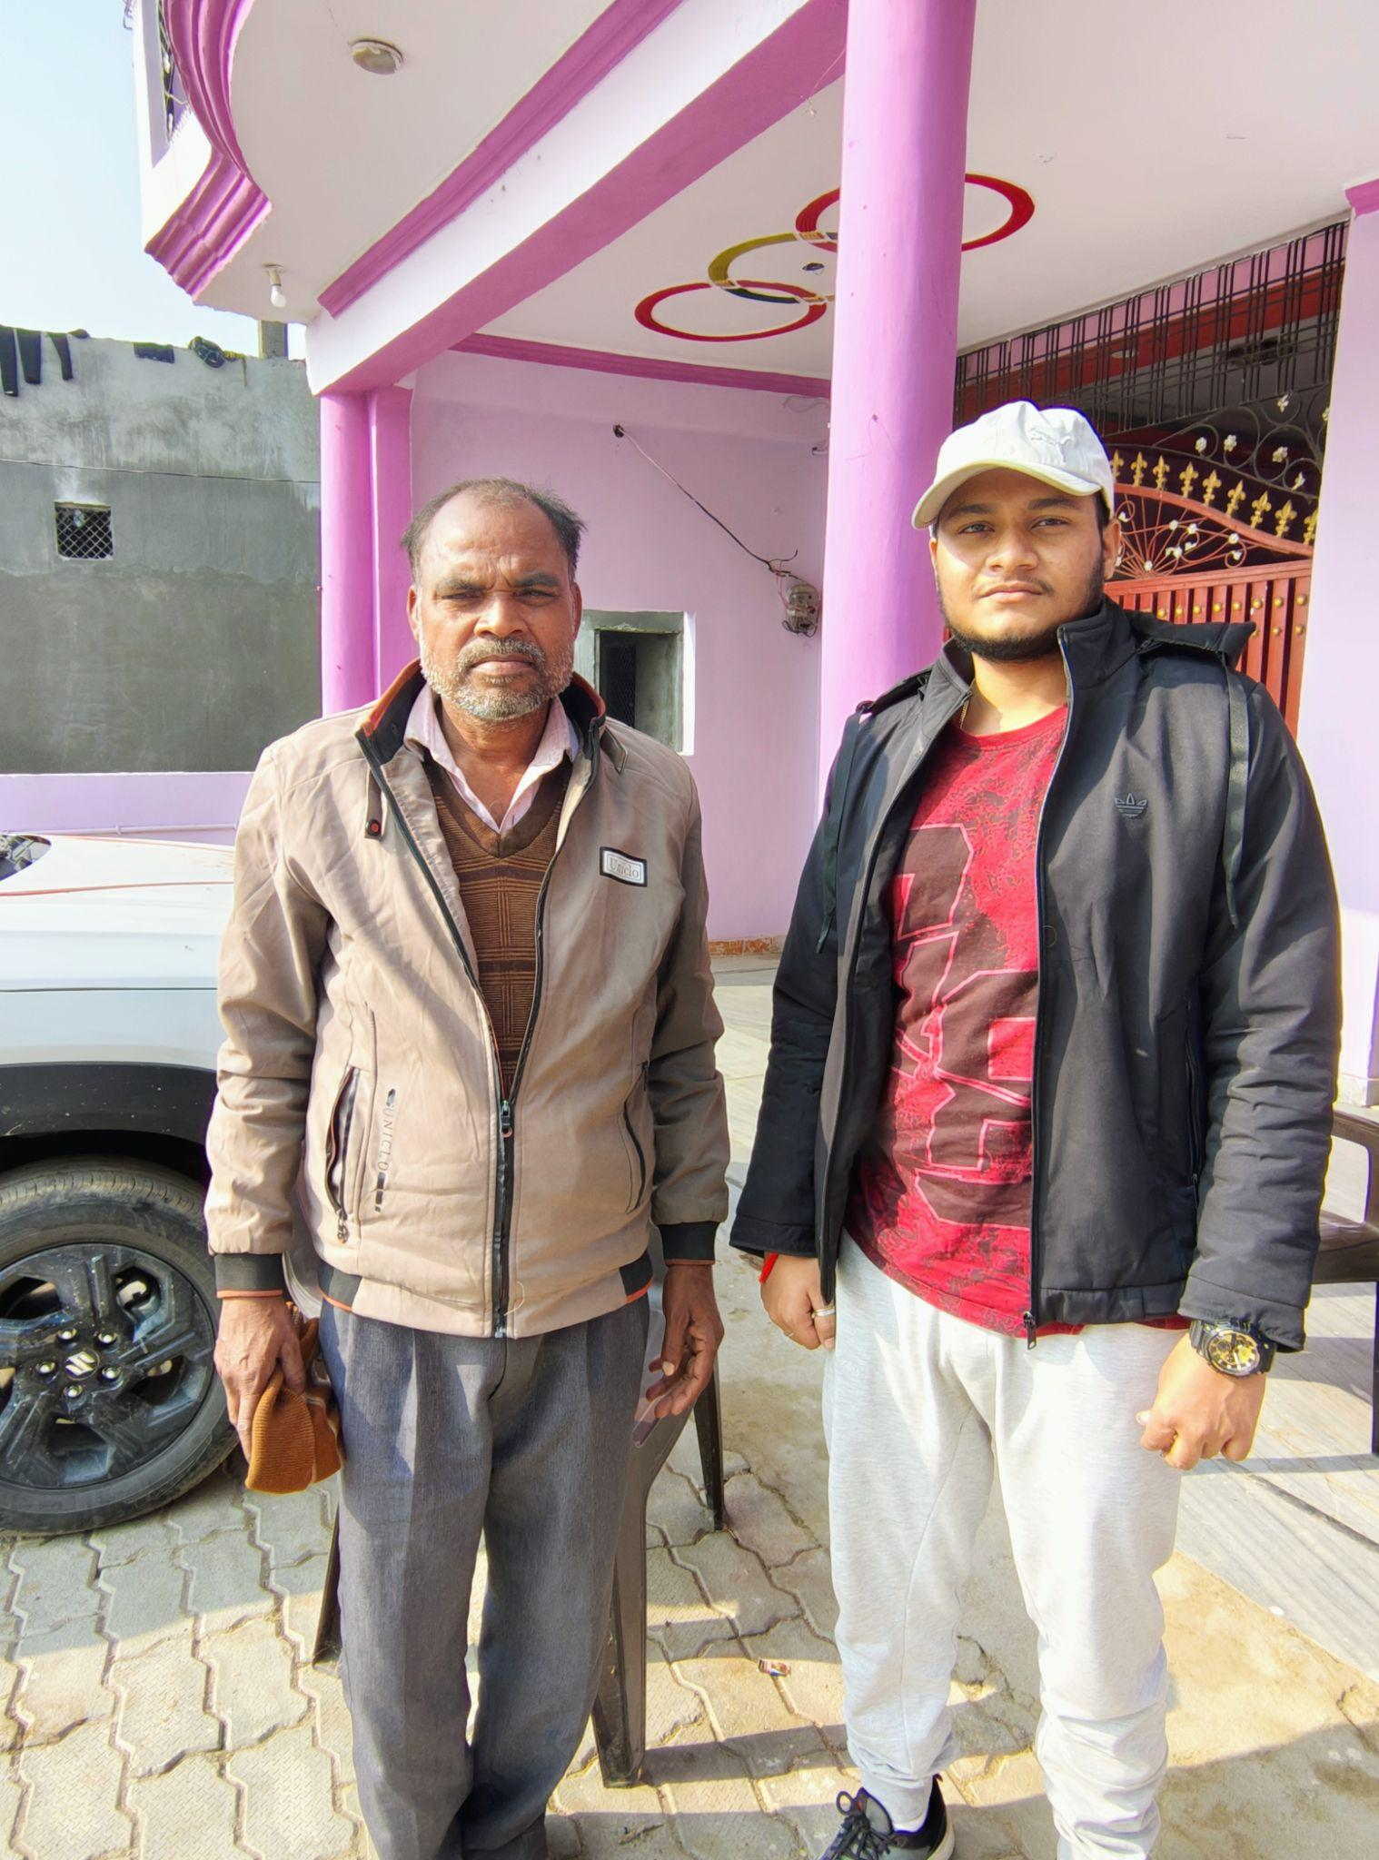
Fig 3.3 : Images of some farmers who participated in the survey
This approach of using multiple ways to record information follows how authentic agricultural surveys should be done so that the data can be checked later. Then all these files were organized using a consistent naming system that connected the surveyor’s initials, when the survey was conducted (MMYYYY), and the farmer's number, which made it easy to keep track of everything. For example : “DY_062025_97” which tells that the surveyor initials are DY (Dipankar Yadav), the survey was conducted in June 2025, and this was the 97th survey done by DY.

3.3 Data Preparation and Standardization

3.3.1 Data Entry and Organization Framework
The data collected through on-field surveys was manually entered into an organized Excel spreadsheet named "Energy Use & Socio-Economic Survey of Indian Agriculture." For each section of the survey questionnaire, a separate sheet was created. For energy usage section a sheet named “Energy Use” was created in which survey questions went down the rows and each farmer-crop pair had its own column. This was done because many farmers grew more than one crop on different pieces of land, and energy use differs by crop, so it wsas needed to keep the information separate for each crop. The data included information from farmers who grew different numbers of crops on their land, ranging from farmers who grew just two crops to those who grew several different ones depending on how much land they had and their farming strategy (Verma et al., 2023; ICAR-IASRI, 2017). Keeping the farmer-crop separation is particularly important for energy analysis because energy inputs and efficiency can differ substantially between crops even on the same farm, for example, paddy and wheat grown by the same farmer will typically need different amounts of water, labor, and fertilizers (Sudesh & Malik, 2018).

3.3.2 Unit Standardization and Format Specification
Standardization of all the numerical data to consistent units was done so that analysis and other operations throughout the analysis become easier across the whole dataset. The unit used for the land areas was hectares, writing smaller areas as decimal parts of a hectare to keep them accurate, for water amounts was liters, converting from other units when farmers gave me information differently (like if they said how many times they irrigated and for how much time they irrigated), diesel amounts were also in liters, converting from other units like tanks or cans that farmers might mention, using their estimates of standard volumes (Stout, 1990; FAO, 2015b), fertilizer and chemical amounts were in kilograms or litres depending upon their physical states, converting from other units like bags or bottles or tanks (which are usually 50 kg for standard fertilizers) or quintals when that's what farmers mentioned, making sure everything was in the same units (ICAR-IASRI, 2017). Labor usage was recorded in man-days using the standard definition of one man-day as one person working a full day (roughly 8-10 hours of work), calculated from what farmers said about how many workers they hired and for how many days. Seed amounts were in kilograms. Crop yields were in kilograms per hectare for each crop-farmer pair (ICAR-IASRI, 2017).
Non-numeric information was sorted into standard types or text formats based on farming research standards. Categories like irrigation method (rainfed, electric pump, diesel pump, canal), fertilizer type (urea, DAP, SSP, mixed fertilizers, organic materials), pesticide category (insecticides, herbicides, fungicides), and farming system (conventional, conservation agriculture) were recorded using fixed lists. This sorting was necessary because when everything is converted to energy later, different input types need different conversion numbers ( Sudesh et al., 2018).

3.4 Data Preprocessing and Cleaning Procedures

3.4.1 Gap Identification and Filling and Classification Strategy
Even with careful surveys and good farmer conversations, gaps were found in the data for various reasons that reflect how farmers actually operate and what they remember. Some farmers could not recall specific information, like the exact brand or type of chemical input they had used or how much fertilizer they had put on. Many farmers buy their seeds and chemical inputs at local agricultural shops (called "beej bhandars" in the area) and take suggestions based on how the crop looks rather than following a planned fertilizer schedule, which means they genuinely cannot tell me exact names or amounts (Verma et al., 2023). Some farmers did not know their own practices well, especially for fertilizers and other chemical inputs and water applied through irrigation or diesel burned across multiple farm jobs that happened at different times. Some key numbers needed (like total water used or total labor hours) had to be worked out from smaller pieces of information that farmers could tell me (Chakraborty et al., 2022).

3.4.2 Gap-Filling Methodology
To handle these gaps while keeping data authentic and avoiding random guesses, a two-step process for filling in missing information was used, based on how agricultural surveys are actually done and what makes sense in real farming communities:
Step 1 - Averaging from Farmers in the Same Village : When a farmer could not tell the exact amount or type of chemical input they used, then the other farmers' data in the same village who grew the same crop and did have complete information about input names and amounts was used. Then the average amount for each input across these reference farmers was calculated, and used that average for the farmer missing data. This approach works well because: (i) farmers in the same village typically shop at the same beej bhandars, where the shopkeepers recommend similar packages to everyone growing the same crop; (ii) most of the farmers in the same village have similar soil types, water access, and weather; and (iii) farmers learn from each other and often use similar farming approaches (Verma et al., 2023; World Bank, 2015). The averaging was done separately for each crop in each village so that crop differences and local conditions were respected (ICAR-IASRI, 2017).
Step 2 - Most Common Inputs : When farmers could not remember the specific name or brand of a chemical they used, then fertilizers, pesticides, herbicides, and fungicides which were most commonly used by farmers in that village for that crop were found out from the data and assigned them to the farmer with missing information. This approach simplifies farmer differences but gives reasonable estimates that match what actually happens in the village's farming (Verma et al., 2023).

3.4.3 Indirect Parameter Estimation
Some key energy inputs had to be calculated from indirect information because farmers don't usually track total resource use in detail:
Total Water Applied : Farmers almost never directly know or remember the total water they apply. However, through survey we collected: (i) the power rating of their water pumps (in kilowatts), (ii) how much water the pump delivers per hour (liters per hour) was found out from agricultural researches and online, (iii) total hours the pump usage for each crop in single application, and (iv) information about how many times they irrigated throughout the growing season. Using the pump delivery rate and total hours of operation, I calculated total water as:
Total Water (liters)=Pump Delivery Rate (L/hour)×Total Pump Hours
For farmers who used canal irrigation or rain-fed systems, I estimated water from how many times they irrigated and typical water amounts for that crop in that season from farming literature (Stout, 1990; FAO, 2015b).
Total Diesel Used : Most farmers did not know their total diesel use but they told: (i) how many hours they used tractors for ploughing and preparation, (ii) hours of other machine use, (iii) hours of diesel pump operation for watering, and (iv) diesel burn rates for each machine type from their knowledge or machine information. Then total diesel use was calculated by multiplying the burn rate (liters per hour, usually 3-4 L/hour for tractors, 1-1.5 L/hour for pumps depending on size) for each machine by the actual hours it ran, then added up all the diesel-powered practices (Sudesh & Malik, 2018; FAO, 2015b).
Total Labor (Man-Days) : Farmers told how many workers they hired for different practices (ploughing, planting, weeding, harvesting, threshing, etc.) and for how many days they worked. So total labor was calculated by adding up all the practices:
Total Man-Days=∑(Number of Workers×Number of Days per Job)
Also the labor of family members working on their own farm was counted as a real energy input even though it is not paid, because the work still required actual energy (ICAR-IASRI, 2017; FAO, 2015b).

3.5 Feature Engineering for Energy Conversion Analysis

3.5.1 Purpose and Goals of Feature Engineering
After cleaning and standardization of the data, there were quantities of different farm inputs (fertilizers by name, pesticides by type, etc.) and crop harvests, but this was not yet in the form needed for energy calculations. Energy use efficiency analysis requires converting all the different inputs into one common energy unit (megajoules, or MJ) using energy conversion factors found in literature. This step of feature engineering transformed raw data into calculated variables ready for energy analysis (Gholami & Sharafi, 2015; ICAR-IASRI, 2017). Feature engineering had three main goals: (i) grouping specific input products into standard nutrient or input types (for example, collecting all the different nitrogen fertilizers urea, DAP, ammonium nitrate into one "total nitrogen" category), (ii) figuring out the nutrient or active ingredient content of chemical inputs (finding out the N-P-K composition in specific fertilizers), and (iii) creating calculated variables for different input groups (Sudesh & Malik, 2018).

3.5.2 Sorting Fertilizers and Other Inputs by Type
A system was created for connecting the specific fertilizer names and brands farmers mentioned to their nutrient content. Farmers often used local names or commercial brands like "urea" (46% nitrogen), "DAP" or "diammonium phosphate" (18% nitrogen, 46% phosphorus), "SSP" or "single superphosphate" (0% nitrogen, 16% phosphorus, 12% sulfur), and others with various compositions, or organic amendments. So, these were sorted by their main nutrients: nitrogen (N), phosphorus (P₂O₅), and potassium (K₂O). Standard nutrient information was taken from agricultural research databases, what was written on fertilizer bags, and agricultural extension materials (FAO, 2015b; Stout, 1990). When possible, it was checked from actual fertilizer bags or checked with local agricultural shops about nutrient contents to be sure. If they were not identified a specific product, normal nutrient amounts were used for that fertilizer category based on standard forms documented in agricultural research (ICAR-IASRI, 2017).
In the same way, pesticides, herbicides, and fungicides were sorted by active ingredient type. Insecticides were seperated into types (organophosphates, pyrethroids, newer compounds), herbicides by how they work (ones that kill certain plants, ones that kill everything), and fungicides by active ingredient. Different pesticide types have different energy values in research literature (Sudesh & Malik, 2018).

3.5.3 Converting Inputs to Energy Units
After sorting inputs, each amount was multiplied by its energy conversion factor to express everything in energy units (megajoules per hectare). The conversion numbers used are standard values from farming research, using numbers calculated in Indian and South Asian agriculture where possible, with international research databases for information not find locally (Gholami & Sharafi, 2015; FAO, 2015b). It was made sure to cite where each number comes from The main energy conversion factors used in the analysis are:
- Diesel fuel: 56.31 MJ/liter (Sudesh et al., 2018; FAO, 2015b)
- Human labor: 1.96 MJ/hour for adult men, adjusted for women (0.8 × standard rate following ICAR guidelines) and for regional differences where documented (FAO, 2015b; ICAR-IASRI, 2017)
- Electric pump running: 11.93 MJ/kWh (Stout, 1990; FAO, 2015b)
- Nitrogen fertilizer (N): 60.6 MJ/kg (Sudesh & Malik, 2018; FAO, 2015b)
- Phosphorus (P₂O₅): 10.1 MJ/kg (FAO, 2015b)
- Potassium (K₂O): 6.7 MJ/kg (FAO, 2015b)
- Pesticides (different types): 250-400 MJ/kg depending on type and active ingredient (Gholami & Sharafi, 2015)
- Seeds (different by crop): Different numbers for each crop from farming research (ICAR-IASRI, 2017)
- Irrigation water: Energy calculated from energy needed for pumping (FAO, 2015b)

3.6 Exploratory Data Analysis (EDA)

3.6.1 Purpose and Methods of Exploratory Analysis
Before detailed energy calculations were performed, the data was examined to visualize, summarize, and describe the patterns of input use, farm features, and crop systems across the survey. Exploratory data analysis served two main purposes: first, to reveal what the distribution and variation looked like for raw input amounts (seeds, water, labor, fertilizers, pesticides) across different crops, farmers, and locations, showing basic patterns of input use in the study area, and second, to identify and visualize connections between variables that might help with later analysis, such as whether farm size related to crop choices, or whether irrigation method affected what was grown (ICAR-IASRI, 2017). By visualizing input patterns before energy conversion, it was possible to establish what the study area looked like and create visual records of farming systems in the villages studied.

3.6.2 Basic Descriptive Statistics
For each main crop, basic statistics were calculated for main input variables. These included average values, median, measures of spread, smallest and largest values, and quartile ranges. These statistics showed what typical input use looked like and how much variation existed for different crops, explaining the range of farming practices across the survey area (Verma et al., 2023; ICAR-IASRI, 2017). Crops that only a few farmers grew were not included because small sample sizes could be misleading.

3.6.3 Visualizations and Graphic Exploration
Multiple visualization methods were employed to show patterns in the data:
It was found that Uttar Pradesh accounted for the largest proportion of records (22.5%), followed by Telangana (20.9%) and Madhya Pradesh (16.9%). The data illustrates the broad geographic coverage of the study, with substantial representation from both northern and southern states, ensuring that regional diversity in agricultural practices was captured.
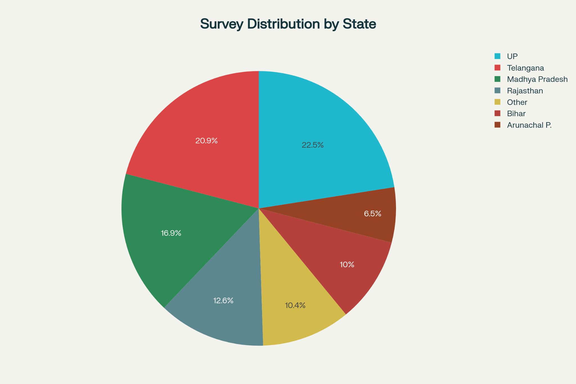
Fig 3.4: This figure shows the state-wise distribution of the survey sample across India.
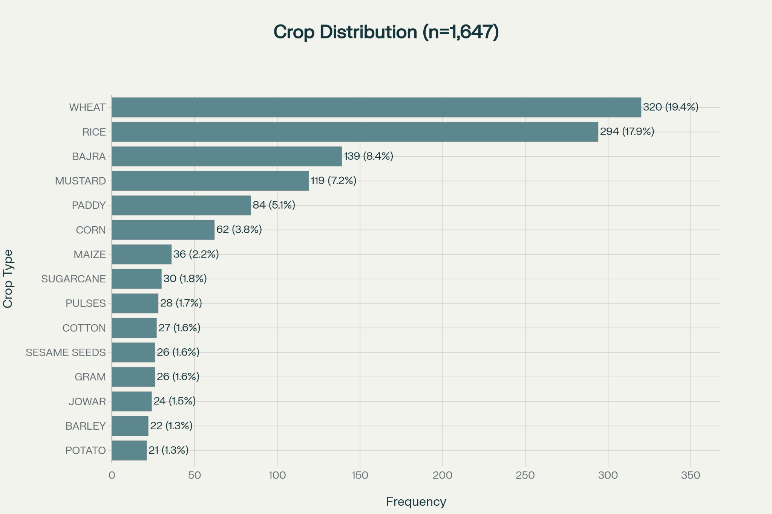
Fig 3.5 : This plot shows the crop distribution pattern, which shows which crop is grown by how many farmers
Crop Distribution Visualizations: Bar charts were created showing how many farmers grew each type of crop, providing an overview of crop variety across the study region. The distributions showed which crops dominated (wheat, paddy, mustard) and how much farmers branched out into secondary crops (millet, pulses, vegetables). These visualizations displayed what sample sizes were available for each crop and which crops were most common in the dataset (Ministry of Statistics & Programme Implementation, 2024).
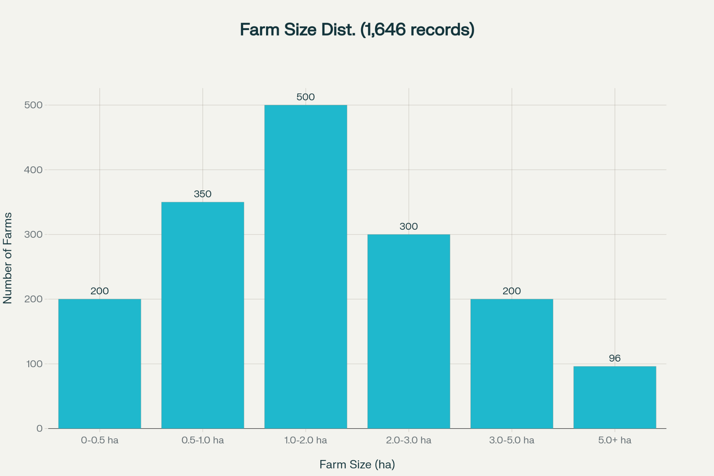
Fig 3.6 : This plot shows the farm size distribution, which tell how many farmers have how much landholding
Farm Size Distribution: Histograms and box plots were generated to show the spread of total cultivation area across surveyed farms, revealing whether the study focused mostly on small or marginal farms, or if larger landholders were included. These visualizations described the scale of farms in the study area and helped explain farming system intensity patterns (Verma et al., 2023).
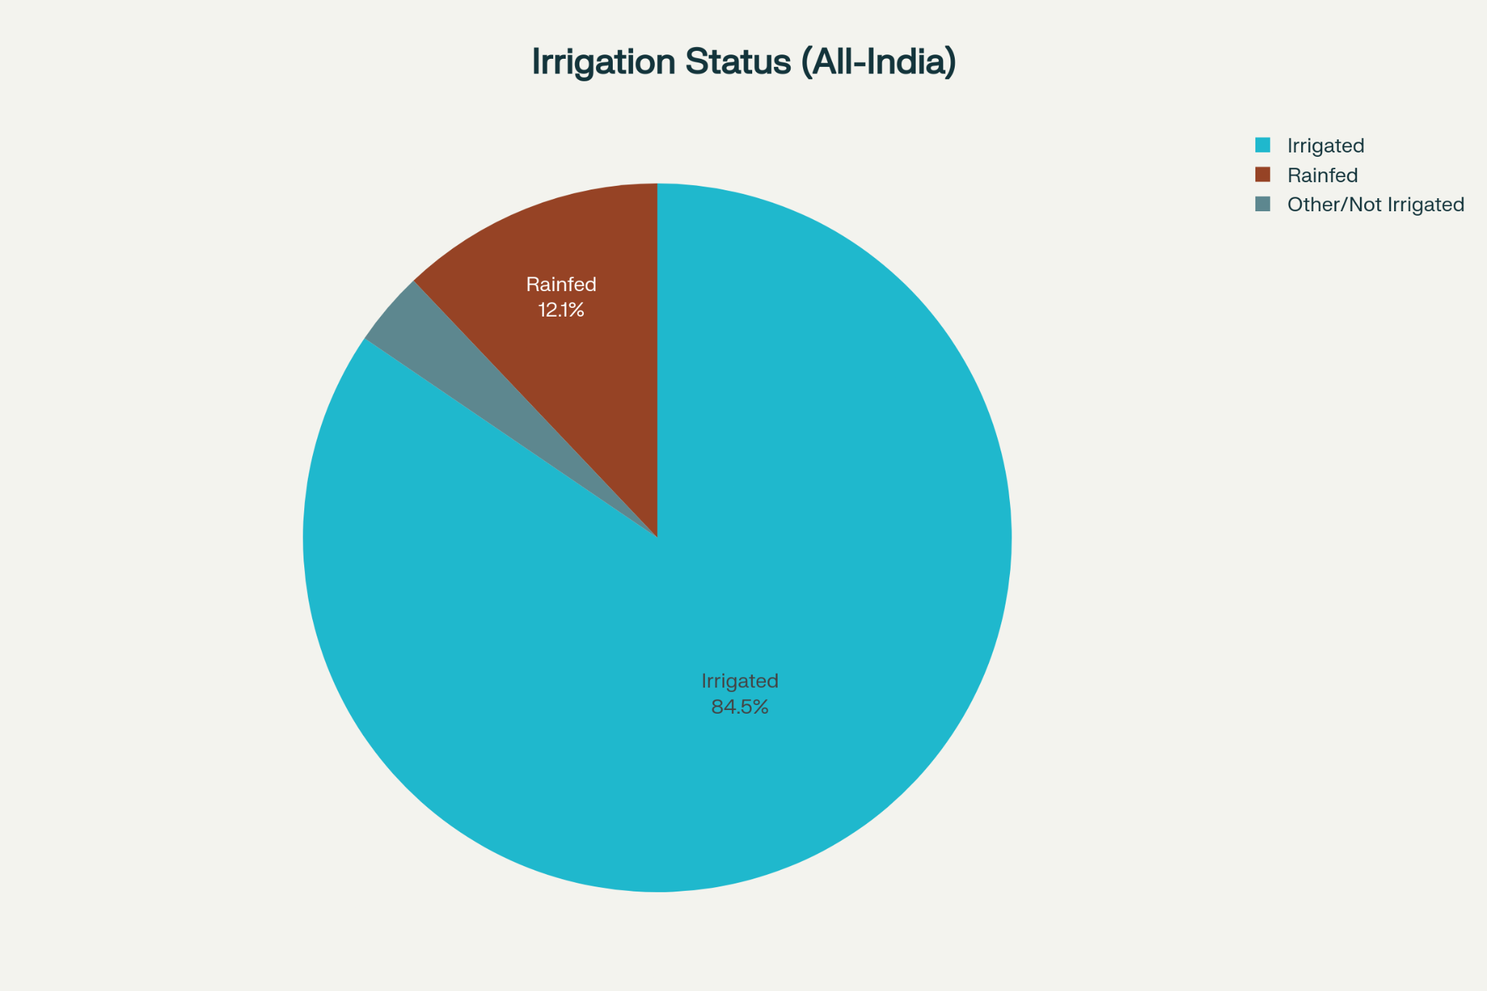
Fig 3.7 : This chart shows what percentage of land in india (the states where survey was done) is irrigated by pumps, rainfed or not irrigated
Irrigation Method Breakdown: Pie charts and stacked bar charts were developed to show what percentage of farms or farm-crop pairs used different irrigation approaches (rain-fed, diesel pump, electric pump, canal irrigation). These visualizations demonstrated how much farms depended on different irrigation methods and revealed infrastructure patterns across the study area (FAO, 2015b; Chakraborty et al., 2022).

3.7 Energy Use Efficiency Analysis Methodology

3.7.1 Basic Concept and Calculation Steps
Energy use efficiency was employed as the main measure for assessing how well farms converted energy investments into crop harvest. The basic energy use efficiency ratio was calculated as:
Energy Use Efficiency (EUE)=Total Energy Output (MJ/ha) / Total Energy Input (MJ/ha)
This simple ratio showed how much energy return farms achieved on their energy investment: values above 1.0 indicated that farms produced more energy in crops than they invested through direct and indirect operations, showing a positive energy balance and suggesting sustainable long-term energy use. Values below 1.0 indicated that energy input exceeded energy output, which was common in modern farming despite high yields in actual kilograms, and demonstrated how dependent farming had become on external energy sources (Pimentel & Stout, 1979; Stout, 1990; Sudesh et al., 2018).
Three additional energy measures were employed to provide further insights beyond the basic ratio:
Net Energy (MJ/ha):
Net Energy=Total Output Energy (MJ/ha)−Total Input Energy (MJ/ha)
This absolute value showed whether a farm produced surplus energy that could be used elsewhere or if it required outside energy support to operate, providing important information for sustainability and energy security (Sudesh & Malik, 2018).
Energy Productivity (kg/MJ):
Energy Productivity=Crop Yield (kg/ha)Total Input Energy (MJ/ha)
This measured how much actual crop (in kilograms) resulted from each megajoule of energy used. This connected energy use to farm output in terms that farmers and policymakers understood (FAO, 2015b).
Specific Energy (MJ/kg):
Specific Energy=Total Input Energy (MJ/ha) / Crop Yield (kg/ha)
This indicated the energy cost (in megajoules) required to produce one kilogram of crop. Lower values indicated more efficient production, while higher values indicated energy-heavy systems (Gholami & Sharafi, 2015).

3.7.2 Calculating Energy Output and Crop Energy Values
Energy output was determined by multiplying harvest (kilograms per hectare) by crop-specific energy content (megajoules per kilogram). Crop-specific energy values were obtained from standard farming databases, research literature, and food information tables, with preference given to values from Indian agricultural research when available (Sudesh & Malik, 2018; FAO, 2015b). For the main crops in the study area, the following energy content values were applied:
- Paddy (rice, cleaned grain): 14.7 MJ/kg (reflecting carbohydrate and protein content in cleaned rice)
- Wheat: 14.9 MJ/kg
- Bajra (pearl millet): 16.5 MJ/kg
- Maize: 15.2 MJ/kg
- Pulses (lentil, chickpea, moong, urad): 16.0-17.0 MJ/kg (varying by legume type due to different protein content)
- Mustard/Rapeseed: 29.0 MJ/kg (much higher due to high oil content)
- Vegetables (cabbage, onion, potato, brinjal): 2.0-5.0 MJ/kg (lower due to high water content and lower energy density)
These values represented the energy content (mainly from carbohydrates, proteins, and fats) of different crops and were standard numbers used consistently in international farming energy research (Stout, 1990; FAO, 2015b). For smaller or regional crops where published values were not available, the average for the crop group (for example, "pulses" or "vegetables") was used, with the understanding that sensitivity checks could be performed if changes to these estimates might affect the main findings (Sudesh & Malik, 2018).

3.7.3 Crop-Level Energy Analysis by State
The main analytical approach employed was to calculate energy use efficiency for each crop separately in each state. This approach recognized that energy patterns often differed across regions due to differences in farmer practices, available resources, infrastructure, and local environmental conditions. For each crop, energy use efficiency was calculated separately for each state (Uttar Pradesh, Madhya Pradesh, Bihar, Rajasthan, Telangana, and Arunachal Pradesh). The process involved:
First, for each farmer growing a specific crop within a state, all energy inputs were summed to obtain total input energy (MJ/ha), and crop yield was converted to energy output (MJ/ha) using crop-specific values. Second, energy use efficiency and related measures were determined for each farmer-crop combination. Third, for each crop in each state, results from all farmers growing that crop were combined by calculating mean values for average crop yield (kg/ha), average total energy input (MJ/ha), average energy output (MJ/ha), average energy use efficiency, average net energy, and average energy productivity. Additionally, measures of variation (standard deviation and quartile ranges) were calculated to assess variation between farmers within each crop-state combination (ICAR-IASRI, 2017).
Finally, crop results were compared across states. For example, wheat efficiency in Uttar Pradesh was compared with wheat efficiency in Bihar, Madhya Pradesh, and other states where wheat was grown. This approach revealed geographic differences in energy efficiency for the same crop and made it possible to investigate whether differences resulted from farmer practices, available resources, or local farming conditions (Verma et al., 2023; Sudesh & Malik, 2018).
This crop-state approach proved superior to calculating an overall efficiency for each crop averaged across all regions because it maintained visibility of geographic differences, recognized that optimal approaches often depended on local conditions, and enabled identification of regional best practices that might be adapted elsewhere (FAO, 2015b; ICAR-IASRI, 2017).

3.7.4 Breaking Down Energy Use by Input Type
In addition to overall energy use efficiency, it was determined which energy inputs contributed most to total input energy. For each farmer-crop pair, the percentage of total energy coming from each input source (nitrogen fertilizer, phosphorus fertilizer, diesel fuel, human labor, irrigation water, pesticides, seeds, etc.) was calculated, expressed both as absolute megajoules and as percentage of total. These breakdowns demonstrated which energy sources dominated production for each crop and how this varied across regions, providing essential information for identifying opportunities to improve efficiency and conserve resources (Sudesh & Malik, 2018; Gholami & Sharafi, 2015).
Additionally, for each input type and each crop-state pair, "input-specific energy ratios" were computed to estimate how efficiently farms utilized each input. For nitrogen fertilizer, the ratio was:
Nitrogen-Specific Energy Ratio = Output Energy (MJ/ha) / Nitrogen Input Energy (MJ/ha)
This ratio showed how effectively farms converted nitrogen energy investment into crop output. Similar ratios were calculated for diesel, labor, and water inputs. These input-specific measures helped identify which inputs were used most efficiently and which showed potential for better management (Gholami & Sharafi, 2015; Sudesh & Malik, 2018).

3.7.5 Comparing Across Different Crops and Areas
To understand energy efficiency findings and identify important factors, efficiency was compared across crops and regions. The same crop was examined across all states where it was grown to identify geographic differences and investigate whether state differences resulted from variations in infrastructure, farmer education, technology adoption, or environmental factors. Additionally, how energy efficiency varied with farm size (comparing small, medium, and larger farms) and irrigation status (comparing rain-fed and irrigated systems) was examined to understand whether scale and water access influenced energy use efficiency (Verma et al., 2023; FAO, 2015b).

REFERENCES

- A comparative study on water and energy indicators for agriculture. (n.d.). Journal of Sustainable Energy and Environment, 7(4), 197–201.
- Bhatt, R., Verma, R., & Singh, P. (2020). Energy use and efficiency in Indian agriculture: An empirical study. International Journal of Agricultural Sustainability, 18(4), 300–315.
- Devi, S., Singh, B., Malik, R. S., & Singh, J. (2018). Energy input-output analysis for production of wheat under Haryana conditions, India. International Journal of Current Microbiology and Applied Sciences, 7(7), 3825–3832.
- Energy Footprints of Rice Production. (2019). ICAR-National Rice Research Institute (NRRI) Publication. Retrieved from https://icar-nrri.in/wp-content/uploads/2019/07/6.-Energy-Footprints-of-Rice-Production_14.pdf
- Energy use efficiency of integrated crop-livestock-fish farming systems. (2024). Indian Journal of Agricultural Sciences, 94(2), 158–166. https://epubs.icar.org.in/ejournal/index.php/IJAgS/article/download/100458/47605/331255
- FAO. (2015). Indicators of energy use in agriculture (A.1). Food and Agriculture Organization of the United Nations. https://www.fao.org/4/x8054e/x8054e09.htm
- Gómez-Calvet, R., Tarazona, A., Mir, R., & Moya, I. (2023). A systematic literature review of data envelopment analysis in agricultural energy research. Frontiers in Sustainable Food Systems, 7, 112–138.
- ICAR. (2024). Energy use pattern and its efficiency in paddy cultivation in Punjab. Indian Ecological Society Journal, 51(1), 45–59.
- IRENA & FAO. (2021). Renewable energy for agri-food systems. International Renewable Energy Agency and Food and Agriculture Organization. https://www.irena.org/-/media/Files/IRENA/Agency/Publication/2021/Nov/IRENA_FAO_Renewables_Agrifood_2021.pdf
- Kannan, K., & Elumalai, S. (2023). Analysis of trends in India's agricultural growth and energy efficiency. Institute for Social and Economic Change Working Paper, 276.
- Kizilaslan, H. (2009). Energy use and input-output analysis for crop production in Turkey. Energy, 34(6), 870–876.
- Life Cycle Assessment in Agriculture. (2022). ATTRA Sustainable Agriculture Program, National Center for Appropriate Technology (NCAT). https://attra.ncat.org/wp-content/uploads/2022/12/life_cycle_assessment.pdf
- Mandal, K. G., Saha, K., & Ghosh, P. K. (2002). Energy input-output analysis of crop production in India. Agricultural Systems, 74(1), 57–70.
- OECD. (2013). Policy Instruments to Support Green Growth in Agriculture. Organisation for Economic Co-operation and Development. https://www.oecd.org/content/dam/oecd/en/publications/reports/2013/10/policy-instruments-to-support-green-growth-in-agriculture_g1g331bc/9789264203525-en.pdf
- Ohio State University Extension. (2018). Fundamentals of energy analysis for crop production (Fact Sheet FABE-6621). Columbus, OH. Retrieved from https://ohioline.osu.edu/factsheet/fabe-6621
- Pimentel, D., & Stout, B. (1979). Energy use in food production. Colorado: Croom Helm Publishers.
- Rahim, A. N., & Dai, X. (2024). Assessment of energy consumption and production in agricultural crops. International Journal of Current Microbiology and Applied Sciences, 13(3), 441–456.
- Renewable Energy: A New Paradigm for Growth in Indian Agriculture. (2024). National Academy of Agricultural Sciences (NAAS) Strategy Paper 10. New Delhi.
- Renewable energy for agri-food systems. (2021). International Renewable Energy Agency (IRENA) and FAO Joint Report. https://www.irena.org/-/media/Files/IRENA/Agency/Publication/2021/Nov/IRENA_FAO_Renewables_Agrifood_2021.pdf
- Roy, R., & Abrol, D. (2024). Energy balance and fuel consumption analysis in rice production of Telangana. Agricultural Research Communications International, 12(2), 112–120.
- Singh, J. M. (2004). On-farm energy use pattern in different cropping systems in Haryana, India. International Institute of Management (University of Flensburg), Germany.
- Soni, P., Salokhe, V. M., & Das, T. K. (2018). Role of renewable energy on agriculture productivity improvement. International Journal of Engineering Science and Emerging Technologies, 7(1), 45–55.
- Stout, B. A. (1990). Handbook of Energy for World Agriculture. London: Elsevier Applied Science.
- Sudesh, D., & Malik, R. (2018). Energy input-output analysis for rice-wheat cropping system under Haryana conditions. Indian Journal of Agricultural Sciences, 88(5), 410–416.
- The Farm Energy Analysis Tool (FEAT). (2011). Ecological Models Group Manual. Pennsylvania State University.
- United Nations Food and Agriculture Organization. (2024). Greenhouse Gas Emissions from Agrifood Systems: Global, Regional, and Country Trends (2000–2022). Rome: FAO.
- U.S. Environmental Protection Agency. (2025). Sources of greenhouse gas emissions. Retrieved from https://www.epa.gov/ghgemissions/sources-greenhouse-gas-emissions
- Verma, R., & Singh, P. (2022). Farm-level energy use patterns and efficiency in India. Energy in Agriculture, 56, 105–116.
- Verma, R., Singh, P., & Bhatt, R. (2023). Patterns of energy consumption in Indian agriculture: A regional study. Journal of Agrarian Change, 23(2), 123–141.
- Yadav, R., & Singh, S. K. (2024). Energy input-output modeling and efficiency assessment in Indian agriculture. Energy Policy, 173, 113–126.
- Zhang, L., Wang, Y., & Cheng, J. (2022). Optimization of energy consumption for soybean production using data envelopment analysis approach. Applied Energy, 299, 117–130.

